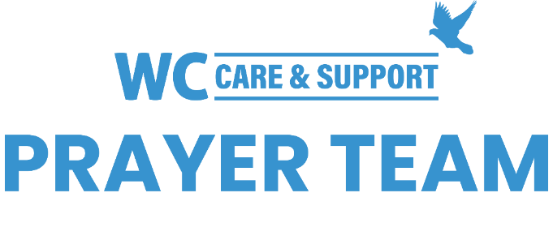
You may submit prayer requests the following link or use this QR code: https://www.whiteschapel.org/prayers.html

Public Prayer List 03-11-2024

Wayne Ackerman, Malta Akins, Clint Bailey, Jack Bair, Jerry Barron, Brie Bauer, Bryan Biddle, Roy Black, Susan Brischke, Terri Broom, The Bryce Family, Ryan Burns, Bobbie Cameron, Connie Center, Freddie Charles, Tim Cline, Ken Cole, Inés Collazo, John and Willene Corder, Aurelio Costa, Luisa Costa, Debbie Dreyfus, Amy Duckworth, Wilma Dykman, Dennis Eaton, Alexandria Eberlein, Lana Elkins, Linda Evans, Ralph Evans, Mark Fidler, Will Fogle, Billie Jean Garner, Dexter Gatlin, Bruce Gill, Shelly Gillette, Carolyn Gillum, Kate Greinert, Curtis Griffith, John Carl Griffith, Sharon Griffith, Mason Grimm, Larry Hoover, Bob Horn, Barb Idol, Gary Jag, Michelle James, Joe Jeffries, Greg King, Cooper Kohan, Nancy Konecki, Bill Lafavers, Eric Larson, Taylor Lynde, Rich Lyon, Sande Lyon, Jonathan Martinez, Sue and Darrell McNutt, Judy Morgan, Thomas W. Morris, Lacey Muckleroy, Tammy Muckleroy, Robin Murphy, Jim Murray, Joy Paprskar, Jennifer Parks, Wren Parson, Rick Peterson, Luke Petta, Barbara Pico, Kathy Pierce, Kathy Poe, Maureen Punko, Jim and Mary Renner, Caroline Rivers, Kristin Robertson, Megan Robison and Brayden Steele, Johnnie Ruth Rogillio, Dan Russell, Jeri Russell, Maverick Savage, Paxton Savage, Carol Schramm, Linda Seedig, Craig Sikes, Linda Sikes, Bruce Slocum, Orville Summey, Steve Swanston, Myra Taunton, Texas Panhandle, Richard Thalluri, Donna Thompson, Robert Thompson, Shane Thompson, Bill Thornton, Linda Torres, Bob Uzelac, Lance Venable, WC Youth Mission Trip, Michael Wenger, Dick Williams, Carroll Willis, Helen Wilson, Leigh Winzeler, Melinda Witt, Lynn Wolford, Jan, Tirol. Recent deaths: The Family of Kay Brandt, The Family of Steve Cullen, The Family of Jerry Dixon, The Family of Steve Easter, The Family of Clare Gatlin, The Family of Ron Golightly, The Family of Ruby Grissett, The Family of Sam Lapp, The McCombs Family, The Family of Matthew Nation, The Family of Mario Rodriguez, The Family of Mary Sue Smith, The Family of Herb Waldrup, The Family of Randy Whisenhunt, The Family of Ruth Williamson, The Family of Larry Winans.

